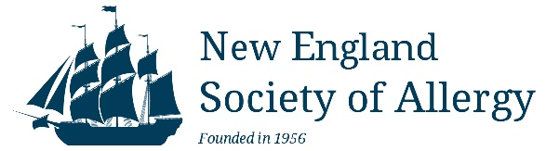
www.newenglandsocietyofallergy.org

Dear Corporate Sponsor,

We are excited to officially welcome your company’s participation as a corporate sponsor for the SPRING and /or FALL 2023 New England Society of Allergy (NESA) educational programs.

UPCOMING NESA EDUCATIONAL PROGRAMS:

SPRING MEETING – March 31, 2023
Allied Health and Doctor meeting- Westford Regency Inn and Conference Center

FALL MEETING – October 21st and 22nd 2023
Doctor Meeting – Seacrest Hotel, Falmouth, MA

These meetings provide unbiased CME and CEU accredited presentations for our 160 members and their nursing, support staff. Detailed information for all our meetings can be found posted on our website at: newenglandsocietyofallergy.org.

Exhibit areas will be set up in areas near, but separated from, the presentations to meet CME credentialing standards. Corporate sponsors will be allowed to set up exhibit tables and attendees will be able to interact with the representatives during several meeting breaks, breakfast and/or lunch. Sales representatives will be welcome to attend the educational sessions and can join us for poster session and the Fall Society Dinner (2 person max), providing the representative remove any name tags with corporate logo’s or pharmaceutical drug names. The New England Society of Allergy takes all the appropriate actions to adhere to the policies and procedures outlined by our CME committee. Our CME committee complies with Standards for Commercial Support of NESA’s Continuing Medical Education which is in accordance to the ACCME Standards for Commercial Support guidelines.

Sponsorship fees are $1500 per company for the Spring 2023 meeting and $1500.00 per company for the Fall 2023 meeting. The fees cover expenses for the exhibit area. Each NESA member pays dues and a fee to attend the meeting to cover the cost of their own meals, beverages and CME recording with the AAAAI. Money that is allocated to fund the exhibit or display at independent educational programs will not be used to fund other aspects of the program (e.g., speaker honoraria, rental fees, or food)

Please visit the NESA website:http://www.newenglandsocietyofallergy.org/meetings/exhibitors/ to make payment and submit the required INDUSTRY AGREEMENT.

Deadline to submit paperwork and payment for the spring meeting is February 24th, 2023.

The NESA Board greatly appreciates your support for these outstanding regional educational programs designed to bring cutting edge scientific information to Allergists/Immunologists in the New England Region. Thank you for your continued support.

Sincerely,

Jordan Scott, MD Christine Barboza
Treasurer Administrative and Exhibit Coordinator

