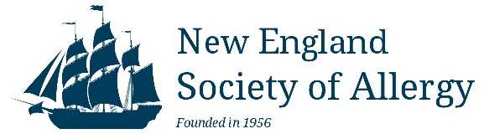 COMMERCIAL SUPPORT ADHERENCE POLICY AGREEMENT

All exhibitor forms must be received by 03/16/2024- SPRING
08/30/2024- FALL
www.newenglandsocietyofallergy.org

Date________________

Company Name: _______________________________________Company Tax ID #: ________ ____________

Item/Drug Promoting: ________________________________________________________________________

Corporate Contact Name:

Corporate Contact Email: ______________________________________________________________________

NESA 2023 Spring and Fall Programs:

SPRING PROGRAM – April 5, 2024 - Westford

FALL PROGRAM – 9/28/2024 and 9/29/2024- Providence
SPONSORSHIP FEES: □ $1500.00 Spring 2024 □ $1500.00 Fall 2024

Payment Options (Send this completed form along with payment)

1) Make payment directly on the NESA website:
http://www.newenglandsocietyofallergy.org/meetings/exhibitors/

and email this form to nesocietyallergy@gmail.com.
SUBJECT LINE: INDUSTRY AGREEMENT- SPRING 2024
- Mail a check payable to “NESA”
New England Society of Allergy
c/o Christine Barboza
36 Osborne Avenue, West Wareham, MA. 02576

and email this form to nesocietyallergy@gmail.com.
SUBJECT LINE: INDUSTRY AGREEMENT- SPRING 2024

Does your company pay via a 3rd party vendor? □ YES  □ NO

Name of 3rd party vendor: _____________________________________________________________

I (we) understand and agree to adhere to the policies and procedures outlined in the Standards for Commercial Support of New England Society of Allergy’s (NESA) Continuing Medical Education established by the NESA CME committee in accordance to ACCME Standards for Commercial Support guidelines.

________________________________________
Signature of commercial representative
NESA is a non-profit organization registered with the Commonwealth of Massachusetts. Tax ID #: 04-2667847

