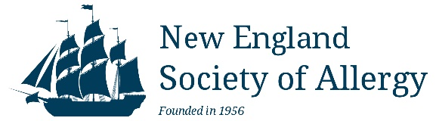 COMMERCIAL SUPPORT ADHERENCE POLICY AGREEMENT

All exhibitor forms and payments must be received by: 03/10/2026- SPRING

Date________________

Company Name: _______________________________________Company Tax ID #: ___________________

Item/Drug Promoting: _______________________________________________________________________

Corporate Contact Name:

Corporate Contact Email: ____________________________________________________________________

NESA 2026 Spring Meeting: April 10, 2026- Worcester, MA

SPONSORSHIP FEES: □ $2500.00 Spring 2026

Payment Options (Send this completed form along with payment)

1) Make payment directly on the NESA website:
http://www.newenglandsocietyofallergy.org/meetings/exhibitors/

and email this form to nesocietyallergy@gmail.com.
SUBJECT LINE: INDUSTRY AGREEMENT- SPRING 2026
2) Mail a check payable to “NESA”
New England Society of Allergy
c/o Joanne Farley
9 McCormack Street, Malden, MA 02148

and email this form to nesocietyallergy@gmail.com.
SUBJECT LINE: INDUSTRY AGREEMENT- SPRING 2026

Does your company pay via a 3rd party vendor? □ YES  □ NO

Name of 3rd party vendor: _____________________________________________________________

I (we) understand and agree to adhere to the policies and procedures outlined in the Standards for Commercial Support of New England Society of Allergy’s (NESA) Continuing Medical Education established by the NESA CME committee in accordance with ACCME Standards for Commercial Support guidelines.

________________________________________
Signature of commercial representative

NESA is a non-profit organization registered with the Commonwealth of Massachusetts. Tax ID #: 04-2667847

