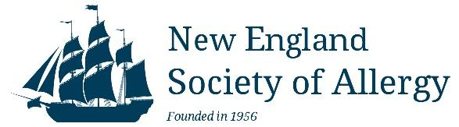
www.newenglandsocietyofallergy.org

Dear Corporate Sponsor,

We are excited to officially welcome your company’s participation as a corporate sponsor for the SPRING 2026 New England Society of Allergy (NESA) educational program.

UPCOMING NESA EDUCATIONAL PROGRAM:

SPRING MEETING – April 10, 2026
Allied Health and Doctor meeting- AC Hotel Worcester, Worcester, MA

Details for the meetings can be found on our website: www.newenglandsocietyofallergy.org.

These meetings provide unbiased CME and CEU accredited presentations for our 160 members and their nursing support staff. Detailed information for all our meetings can be found on our website at: newenglandsocietyofallergy.org.

Exhibit areas will be set up in areas near, but separated from, the presentations to meet CME credentialing standards. Corporate sponsors will be allowed to set up exhibit tables, and attendees will be able to interact with the representatives during several meeting breaks, breakfast and/or lunch. Sales representatives will be welcome to attend the educational sessions and can join us for poster sessions, and the Fall Society Dinner (2 person max), providing the representative remove any name tags with corporate logos or pharmaceutical drug names. The New England Society of Allergy takes all the appropriate actions to adhere to the policies and procedures outlined by our CME committee. Our CME committee complies with Standards for Commercial Support of NESA’s Continuing Medical Education which is in accordance with the ACCME Standards for Commercial Support guidelines.

Sponsorship fees are $2500 per company for the Spring 2026 meeting. The fees cover expenses for the exhibit area. Each NESA member pays dues and a fee to attend the meeting to cover the cost of their own meals, beverages and CME recording with the AAAAI. Money that is allocated to fund the exhibit or display at independent educational programs will not be used to fund other aspects of the program (e.g., speaker honoraria, rental fees, or food)

Please visit the NESA website:http://www.newenglandsocietyofallergy.org/meetings/exhibitors/ to make payment and submit the required INDUSTRY AGREEMENT.

Deadline to submit paperwork and payment for the spring meeting is March 10, 2026

The NESA Board greatly appreciates your support for these outstanding regional educational programs designed to bring cutting edge scientific information to Allergists/Immunologists in the New England Region. Thank you for your continued support.

Sincerely,
Rung-chi Li JoAnne Farley and Valerie Medeiros
Treasurer Administrative and Exhibit Coordinators

